**Python Coding Challenge**

**Q2)**

**(i)Execute with one example Lambda Functions in Python**

**(ii)Read JSON Strings to Python dictionary or lists**

**SOLUTION:**

**(i)Executing with one example Lambda Functions in Python**

In Python, a lambda function is a small anonymous function defined using the ‘lambda’ keyword which is used to create one-line functions without using the ‘def’ keyword. In Python we can use Lambda with map(),filter()and sorted()

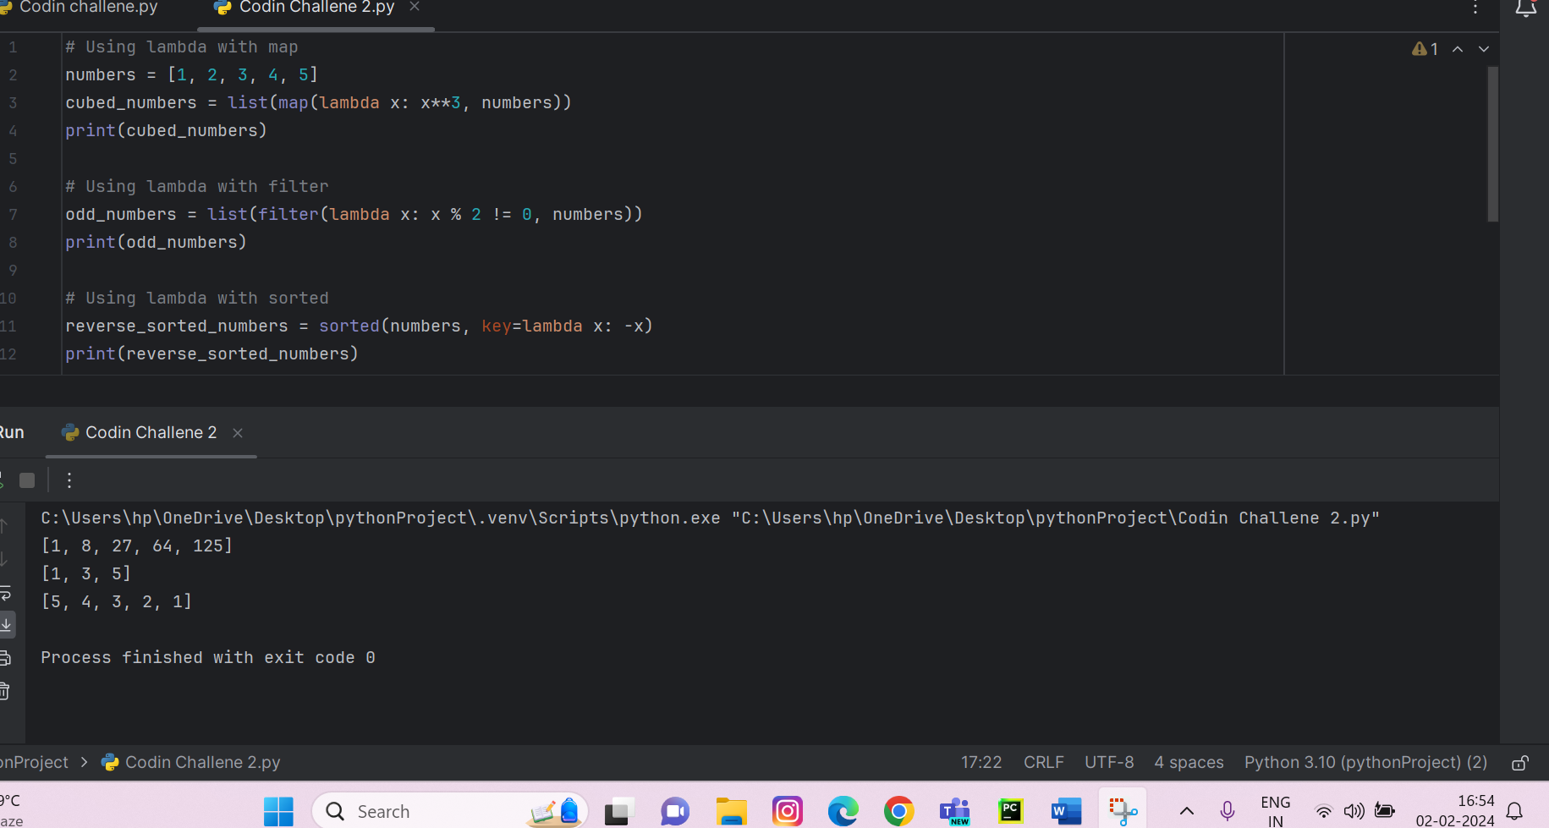

**(ii)Read JSON Strings to Python dictionary or lists**

JSON stands for JavaScript Object Notation. It is basically a data interchange format that is easy for us to read and write. It is widely used to transmit data between a server and web application, as well as for configuration files and data storage.

To read JSON string we use json.loads() method and to read a JSON file we use json.load() method. Here we have to provide a example of reading JSON string to Python Dictionary and here is the example for that:

